


Test Script Builder
User Guide
APAC Services Team
Document Control
Status: Draft | Version: v0.1 | Date: 02-Mar-2026
Version History
Date | Version | Author | Scope
02-March-2026 | v0.1 | Sameer Menon | Draft

Approvals
Name | Title/Role | Organisation | Date

Document Classification
CONFIDENTIAL

Contents
1. Introduction 6
1.1. Background 6
1.2. Key Features 6
1.3. System Requirements 6
2. Getting Started 7
2.1. Launching the Application 7
2.2. The Wizard Interface 7
3. Step 1: Upload Document 8
3.1. Supported File Types 8
3.2. Upload Methods 8
4. Step 2: Select Content 9
4.1. Overview — Mode Toggle Bar 9
4.2. Header Mode 10
4.2.1. How to use Header mode 10
4.2.2. Toolbar controls 10
4.3. Pages Mode 11
4.3.1. Page range selector 11
4.3.2. Individual page selection 11
4.4. Text Mode (Free-form Highlighting) 12
4.4.1. How to select text 12
4.4.2. Managing selections 13
4.5. Character Limit 13
5. Step 3: Edit Prompt 14
5.1. Preview Mode 14
5.2. Edit Mode 15
5.3. Prompt Statistics 15
6. Step 4: Generate Tests 16
6.1. The 4-Stage AI Pipeline 16
6.2. Progress Indicators 16
7. Step 5: View Results 17
7.1. Scenario Cards 17
7.2. Test Steps Table 18
7.2.1. Priority Levels 18
7.3. Export to Excel 18
7.4. Export to Azure DevOps 18
7.5. Regenerate and Start Over 19
7.6. Raw JSON and Sent Text 19
8. Tips and Best Practices 20
8.1. Document Preparation 20
8.2. Content Selection Strategy 20
8.3. Prompt Customisation 20
9. Troubleshooting 21
Appendix A: Keyboard Shortcuts 22
Appendix B: Supported File Formats 23

Tables
Table 1: Supported File Types 8
Table 2: Toggle Bar details 9
Table 3: Matcha Missions Usage 16
Table 4: Excel Test Script Export Columns 18

Figures
Figure 1: The stepper navigation bar showing all 5 steps 7
Figure 2: The upload zone on Step 1 8
Figure 3: The mode toggle bar with Headers, Pages, and Text options 9
Figure 4:Header mode showing H1/H2 sections with checkboxes 10
Figure 5: Pages mode with page range selector and individual checkboxes 11
Figure 6: Text mode with highlighted selections and selection chips 12
Figure 7: Step 3 in Preview mode showing the assembled prompt 14
Figure 8: Step 3 in Edit mode with the prompt text area 15
Figure 9: Pipeline in progress with stages completing sequentially 16
Figure 10: Results view showing generated test scenario cards 17
Figure 11: The results toolbar with export and action buttons 18

Introduction

Background
The Test Script Builder is an AI-powered tool that transforms your requirements, functional, or user specification documentation into structured, comprehensive test scripts. It uses a four-stage pipeline powered by Matcha AI to decompose documents, identify expected outcomes, build test flows, and compile a final test report.
Instead of manually writing test cases from requirements documents, you upload your document, select the content you want tested, and let the AI generate ready-to-use test scenarios complete with steps, expected results, and preconditions.

Key Features
- 5-step wizard - Guided workflow from document upload to test script download
- 3 content selection modes - Headers, Pages, and free-form Text highlighting
- 4-stage AI pipeline - Identifying Test Areas, Defining Expected Outcomes, Creating Test Flows, and Compiling the Test Report
- Real-time progress - Server-Sent Events stream pipeline status to the browser
- Excel export - Styled .xlsx workbook with one scenario per section
- Azure DevOps export - AZDO-formatted Excel ready for Test Plans import
- Built-in help page - Comprehensive documentation accessible from the header

System Requirements
- A modern web browser (Chrome, Edge, Firefox, or Safari)
- Network access to the application server
- No installation required on the client side

Getting Started

Launching the Application
Open your web browser and navigate to the application URL provided by your team (typically http://localhost:3000 for local development). The application loads immediately with no login required.

The Wizard Interface
The Test Script Builder uses a 5-step sequential wizard. A stepper bar at the top of the screen shows your progress through the workflow:

Figure 1: The stepper navigation bar showing all 5 steps

1. Upload Document — Select and upload your requirements file
2. Select Content — Choose which parts of the document to include
3. Edit Prompt — Review and optionally customise the AI prompt
4. Generate Tests — Run the AI pipeline and watch progress
5. View Results — Review scenario cards and export to Excel or Azure DevOps
You can click on any completed step in the stepper bar to navigate back and adjust your selections. Your progress and choices are preserved.

Step 1: Upload Document
The first step lets you upload the requirements document that will be parsed and fed into the AI pipeline.

Supported File Types
Table 1: Supported File Types
Format | Extension | Parser | Notes
Word Document | .docx | Mammoth.js | Extracts H1/H2 headings and body text. Best format for structured documents.
PDF Document | .pdf | PDF.js | Extracts text by page. Heading detection uses font-size heuristics.
Plain Text | .txt | Built-in | No heading structure. Content is divided into page-sized chunks.
CSV Spreadsheet | .csv | Built-in | Tabular content treated as a single section.

Upload Methods
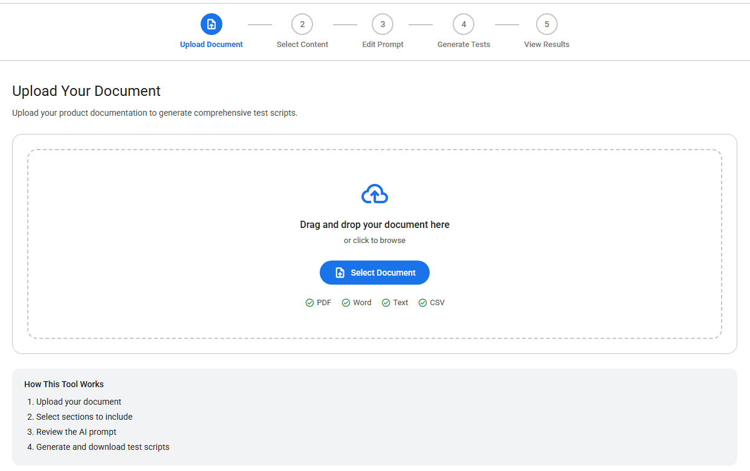
Figure 2: The upload zone on Step 1

There are two ways to upload your document:
- Drag and drop — Drag a file from your desktop or file explorer directly onto the upload zone.
- Click to browse — Click the upload zone or the "Select Document" button to open the file picker.
After a successful upload, the tool automatically parses the document and advances to Step 2 (Content Selection). You can return to Step 1 at any time to upload a different file.
Tip: Word documents (docx) with clear H1 and H2 heading structure produce the best results, as the parser can accurately identify sections.

Step 2: Select Content
This is the most important step in the workflow. Here you choose exactly which content from your document will be sent to the AI pipeline for test generation. Step 2 provides three selection modes, each suited to different document types and use cases.

Overview — Mode Toggle Bar
A segmented toggle bar at the top of the page lets you switch between the three selection modes. The tool automatically selects the best default mode based on your document type. Greyed-out tabs indicate that mode is not available for this file.
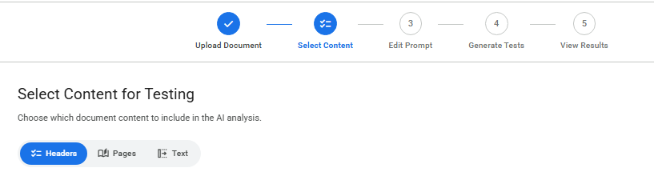
Figure 3: The mode toggle bar with Headers, Pages, and Text options

Table 2: Toggle Bar details
Mode | Best For | Available When
Headers | Well-structured DOCX and PDF files with H1/H2 headings | Document has detectable headings
Pages | PDFs or documents without clear heading structure | PDF files (always) or documents without headings
Text | Selecting specific passages from any document type | Always available for all file types

Header Mode
Header mode is the default when your document has a clear heading structure (H1 and H2 headings). It displays your document as a list of sections, each with a checkbox.
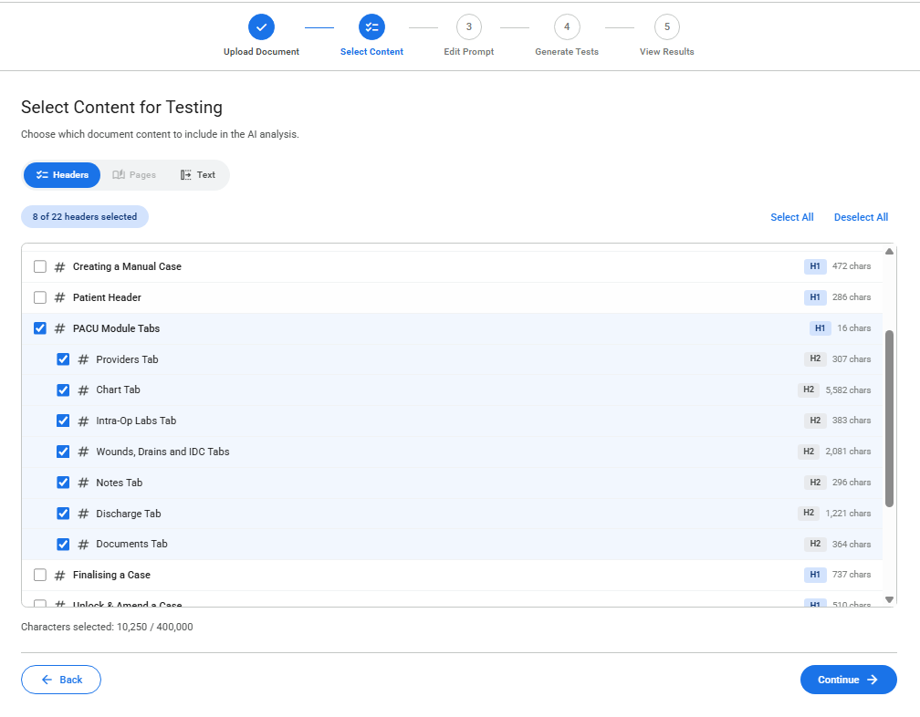
Figure 4:Header mode showing H1/H2 sections with checkboxes

How to use Header mode
- Each section shows its heading level (H1 or H2 badge), title, and character count.
- Check the checkbox next to each section you want to include in the test generation.
- Checking an H1 heading automatically selects all its child H2 sections beneath it.
- Unchecking an H1 heading deselects all its children.

Toolbar controls
- Select All — Checks every section in the list.
- Deselect All — Unchecks every section in the list.
The character counter at the bottom shows the total size of your selected content. Keep this below 400,000 characters.

Pages Mode
Pages mode lets you select content by page number. For PDF files, these are the actual document pages. For other file types (DOCX without headings, TXT, CSV), the tool creates approximate page-sized chunks of around 3,000 characters each.
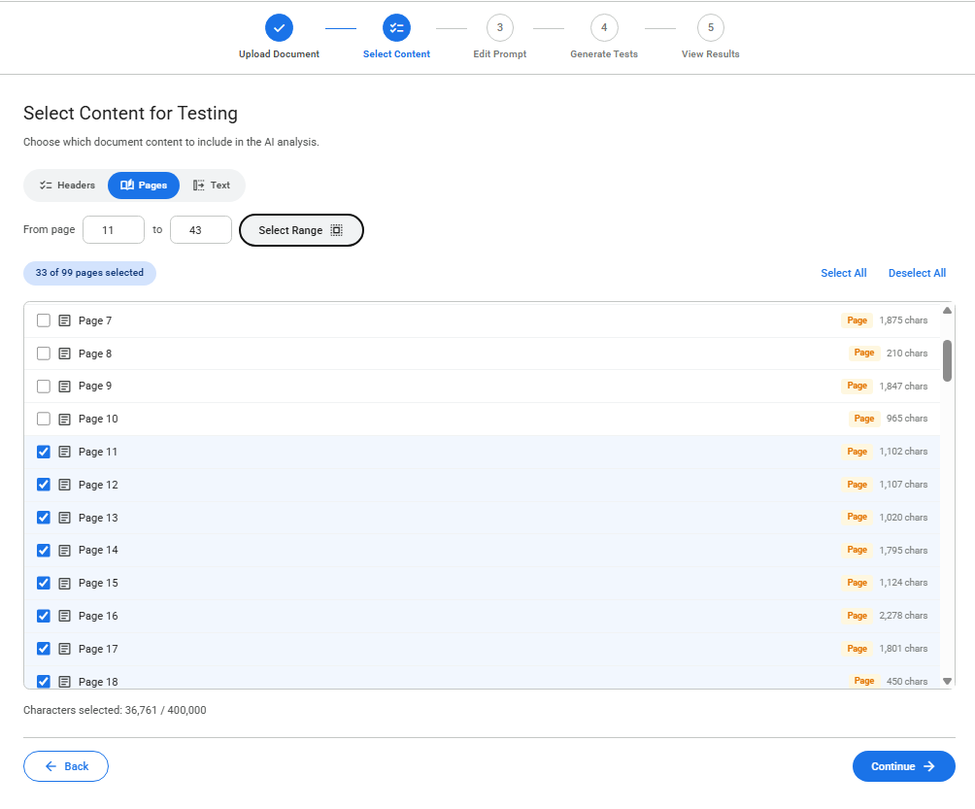
Figure 5: Pages mode with page range selector and individual checkboxes

Page range selector
At the top of the page list, you will find a page range selector with "From" and "To" number inputs. Enter the start and end page numbers, then click the "Select Range" button to check all pages in that range at once.

Individual page selection
- Each page is listed with its page number and character count.
- Toggle individual pages on or off using their checkboxes.
- Use Select All / Deselect All for batch operations.
Tip: Pages mode is particularly useful for PDF files where heading detection may be imprecise. You can select just the pages that contain functional requirements and skip cover pages, appendices, or glossaries.

Text Mode (Free-form Highlighting)
Text mode displays the full document text in a scrollable panel and lets you highlight specific passages. This gives you the most precise control over exactly which content is sent to the AI.
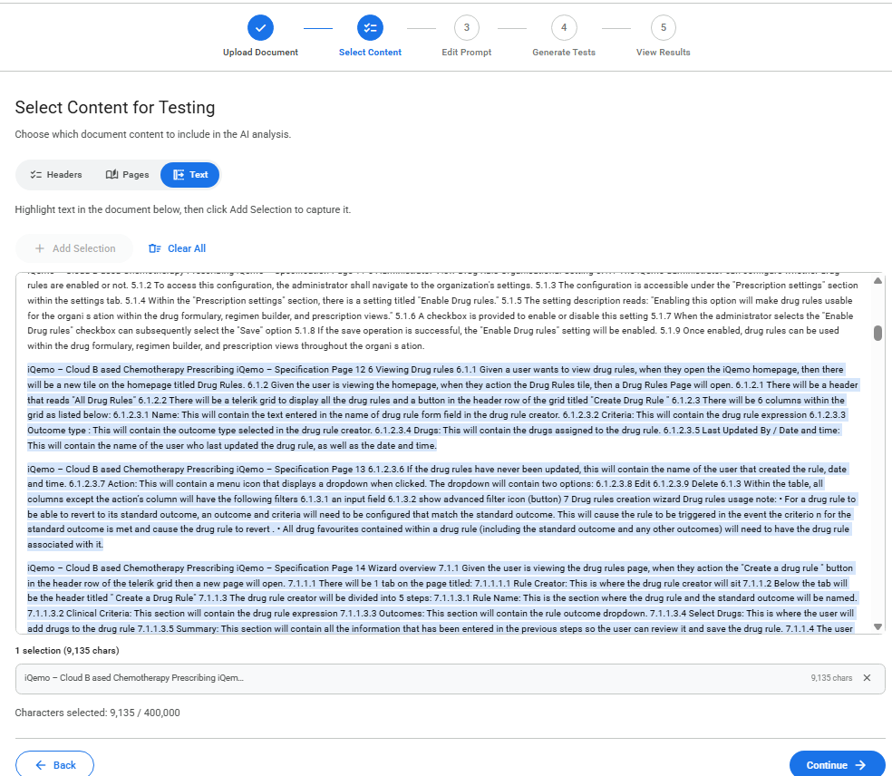
Figure 6: Text mode with highlighted selections and selection chips

How to select text
1. The full document text is displayed in the scrollable text area.
2. Click and drag your mouse to highlight a region of text you want to include.
3. Click the "Add Selection" button (it becomes active once text is highlighted).
4. The selected region is visually highlighted in the document with a coloured marker.
5. Repeat to add as many selections as you need.

Managing selections
- Each captured selection appears as a chip below the text area showing a preview of the text and its character count.
- Click the remove button on any chip to delete that selection.
- Use "Clear All" to remove all selections at once.
- If you add overlapping selections, they are automatically merged into a single contiguous range.
Tip: Text mode is ideal when you need to cherry-pick specific paragraphs or passages from a larger document. It is always available regardless of document type.

Character Limit
Across all three modes, the total selected content must remain below 400,000 characters. The character counter at the bottom of the step displays your current total:
- When under the limit, the counter displays in the default colour.
- When you exceed the limit, the counter turns red and the Continue button is disabled.
- To resolve this, deselect some content until you are back under the limit.
Note: Switching between modes preserves your selections in each mode independently. Your Headers selections are kept when you switch to Pages mode and vice versa.

Step 3: Edit Prompt
Step 3 shows you the assembled prompt that will be sent to the AI pipeline. This prompt combines a system instruction (telling the AI to act as a QA test analyst) with the document content you selected in Step 2.

Preview Mode
By default, the prompt is shown in read-only preview mode. This lets you verify that the right content is included before generating tests.
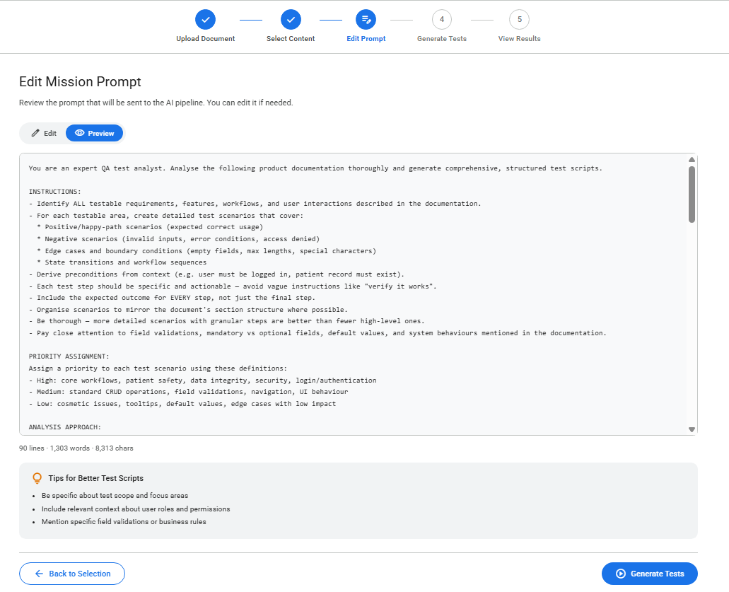
Figure 7: Step 3 in Preview mode showing the assembled prompt

Edit Mode
Click the "Edit" toggle button to switch to edit mode. In this mode, the prompt becomes a full text editor where you can modify, add, or remove content.
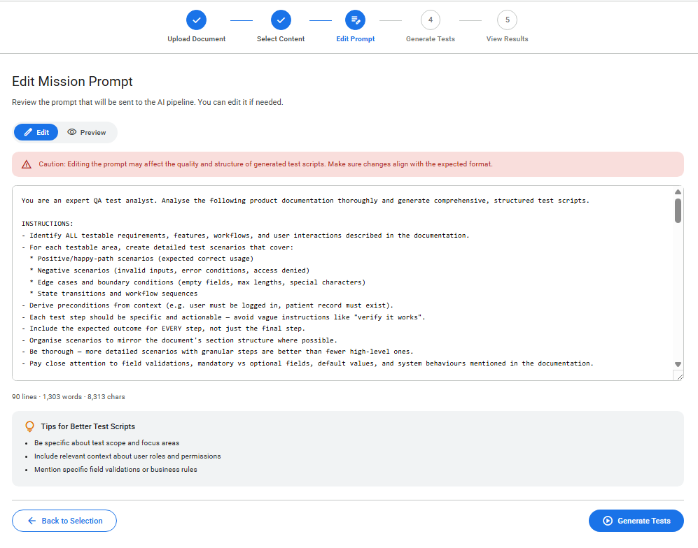
Figure 8: Step 3 in Edit mode with the prompt text area
Warning: Editing the prompt may affect the quality and structure of the generated test scripts. Make sure any changes align with the expected input format for the AI pipeline.

Prompt Statistics
Below the prompt, a statistics line displays the total number of lines, words, and characters. This updates in real-time as you edit the prompt.
Tip: If you are unsure about editing, leave the prompt in Preview mode and click "Generate Tests" to proceed with the default assembled prompt.

Step 4: Generate Tests
Step 4 sends your assembled prompt through a four-stage AI pipeline. Each stage is a specialised Matcha AI mission that builds on the output of the previous stage.

The 4-Stage AI Pipeline
Table 3: Matcha Missions Usage
Stage | Mission Name | Description
1 | Document Decomposer | Decomposes the document into testable functional areas and user-facing behaviours.
2 | Assertion Normaliser | Cross-references the original document to define expected results for each test area. Anti-hallucination rules ensure outputs are grounded in the source material.
3 | Scenario Builder | Builds structured test scenarios with step-by-step flows, preconditions, and validation criteria.
4 | Test Script Materialiser | Materialises the final output as a structured JSON report containing all test scenarios.

Progress Indicators
While the pipeline runs, you will see real-time progress indicators:
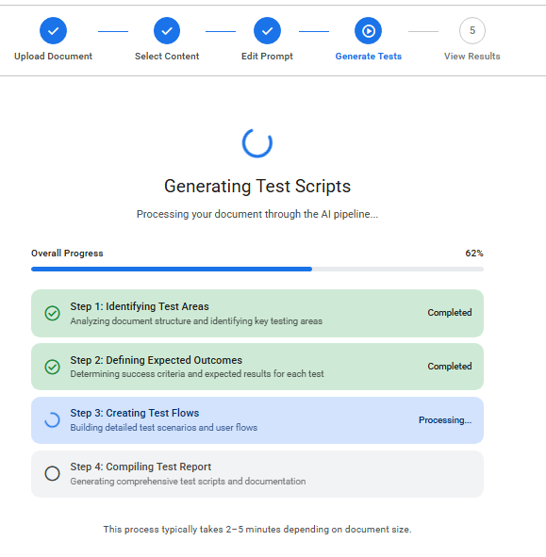
Figure 9: Pipeline in progress with stages completing sequentially
- Spinning icon — The currently running stage displays a spinning icon with a blue background.
- Green checkmark — Completed stages display a green checkmark icon.
- Progress bar — A horizontal bar fills from 0% to 100% as each stage completes.
- Percentage display — The current completion percentage is shown above the progress bar.
Note: The pipeline typically takes 2 to 5 minutes depending on document size. Do not close the browser tab while it is running. When all four stages complete, the wizard automatically advances to Step 5.

Step 5: View Results
Step 5 displays the generated test scenarios as individual cards. Each card represents one test scenario from the AI output.

Scenario Cards
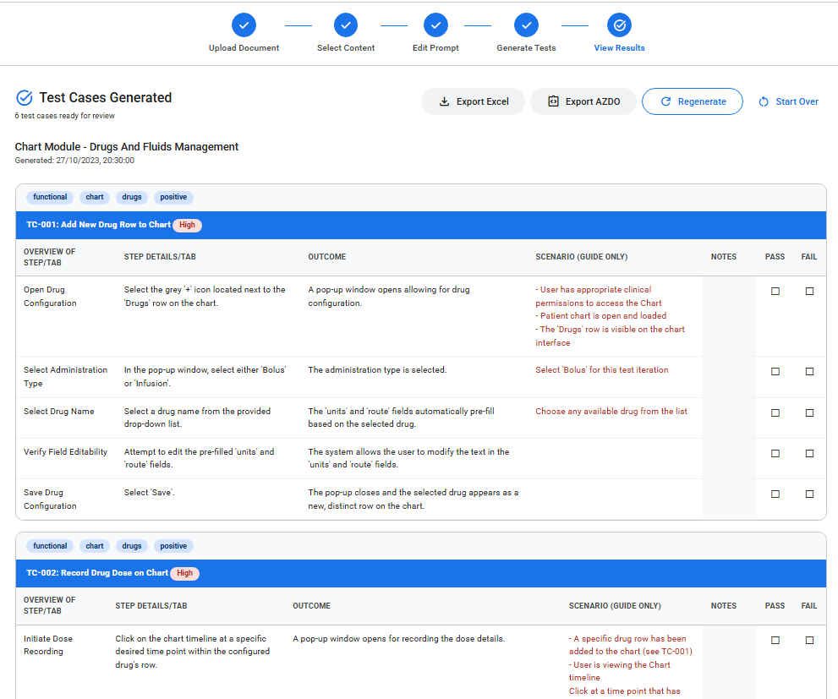
Figure 10: Results view showing generated test scenario cards
Each scenario card contains a header row with the scenario ID (e.g. SC-001), title, and priority badge. Below the header is a structured table of test steps.

Test Steps Table
Each scenario card contains a table with the following columns:
Table 4: Excel Test Script Export Columns
Column | Description
Overview of Step | High-level description of the action to perform
Step Details | Detailed instructions for executing the step
Outcome | The expected result after performing the action
Scenario (Guide Only) | Contextual guide including preconditions (first row only)
Notes | Editable field — click to add your own annotations before export
Pass | Checkbox column for marking passed steps during test execution
Fail | Checkbox column for marking failed steps during test execution

Priority Levels
Scenarios are tagged with one of three priority levels:
- High — Critical functionality that must be tested first.
- Medium — Important features that should be tested in standard cycles.
- Low — Edge cases or minor features to test when time permits.

Export to Excel
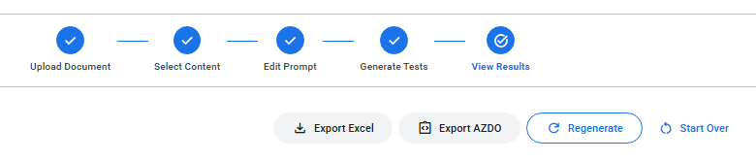
Figure 11: The results toolbar with export and action buttons

Click the "Export Excel" button to download a styled .xlsx workbook. The file contains all scenarios with professional formatting including coloured headers, borders, and auto-fitted column widths.
File naming: Test_Scenarios_YYYY-MM-DD_HH-MM.xlsx

Export to Azure DevOps
Click the "Export AZDO" button to generate an Azure DevOps-compatible Excel file. You will be prompted to enter an Area Path (e.g. Project\Team\Sprint). Each scenario is placed on its own worksheet with AZDO-specific columns including Work Item Type, Area Path, and State.
File naming: AZDO_Test_Scenarios_YYYY-MM-DD_HH-MM.xlsx

Regenerate and Start Over
- Regenerate — Re-runs the AI pipeline with the same prompt. Click "Regenerate" if the initial results need improvement.
- Start Over — Resets the entire wizard back to Step 1, clearing all data. A confirmation dialog will appear before proceeding.
Tip: The Notes column in each scenario card is editable. Click on any Notes cell to add your own annotations before exporting to Excel. These annotations will be included in the exported file.

Raw JSON and Sent Text
Below the scenario cards, two collapsible sections let you inspect the underlying data:
- Raw JSON — Expand this toggle to see the complete JSON response from the AI pipeline. Useful for debugging missing or incomplete scenarios.
- Sent Text — Expand this toggle to review the exact prompt that was sent to the AI, including any edits you made in Step 3.

Tips and Best Practices

Document Preparation
1. Use structured headings. Documents with clear H1/H2 heading hierarchy produce the best section parsing results, especially in .docx format.
2. Keep sections focused. Each section should cover a single feature or functional area. Avoid combining unrelated content under one heading.
3. Prefer DOCX over PDF. Word documents preserve heading structure more reliably. PDF heading detection relies on font-size heuristics which can be imprecise.

Content Selection Strategy
4. Be selective. Including too much content produces longer processing times and may dilute test quality. Focus on content containing functional requirements.
5. Watch the character count. Stay well below the 400K limit for best results. Smaller, focused inputs generally produce higher quality tests.
6. Use the right mode. Headers mode for structured DOCX files, Pages mode for PDFs, and Text mode when you need precise control.

Prompt Customisation
7. Review before generating. Always check the assembled prompt in Step 3 before running the pipeline. Ensure the system prompt and document content look correct.
8. Avoid removing the system prompt. The system prompt at the top of the assembled text contains important instructions for the AI. Removing or significantly altering it may produce poor results.

Troubleshooting
Common issues and their solutions:
Issue | Possible Cause | Solution
File upload fails | Unsupported file type or corrupted file | Ensure the file is a .docx, .pdf, .txt, or .csv. Try re-saving the file.
No headings detected after upload | Document has no headings or uses non-standard formatting | Add H1/H2 headings to your Word document. For PDFs, ensure text is selectable (not a scanned image). Try Pages or Text mode instead.
Character limit exceeded | Too much content selected | Deselect content that is less relevant to testing, such as appendices or glossaries.
Pipeline stalls or times out | Network issues or API overload | Wait a moment and click Regenerate. If persistent, check your internet connection.
Incomplete or missing scenarios | Input too large or ambiguous for the AI | Try with less, more focused content. Check the Raw JSON output to see what the AI returned.
Excel file is empty or malformed | JSON output was not in the expected format | View the Raw JSON to confirm valid output. Try regenerating the tests.
AZDO export missing area path | Dialog was cancelled or left blank | Click Export AZDO again and enter the area path when prompted (e.g. Project\Team\Sprint).
Warning: If the pipeline fails repeatedly, check that the server is running and that the MATCHA_API_KEY environment variable is correctly set.

Appendix A: Keyboard Shortcuts
Shortcut | Action | Context
Ctrl + Enter | Continue to next step | Steps 2 and 3
Esc | Close dialog | Confirmation and input dialogs
Enter | Confirm dialog action | Confirmation and input dialogs

Appendix B: Supported File Formats
Format | Extension | Heading Detection | Page Detection | Best Selection Mode
Word Document | .docx | H1/H2 native headings | Synthetic chunks (if no headings) | Headers
PDF Document | .pdf | Font-size heuristics | Native PDF pages | Pages
Plain Text | .txt | None | Synthetic chunks (~3000 chars) | Text or Pages
CSV Spreadsheet | .csv | None | Single chunk | Text
For all formats, the full document text is always available in Text mode for free-form selection.

